**Name: Khan Md Shahedul Islam**

**Student id: 2018380130**

Assignment 3:

I have written the simple program using Java language. The program has 3 classes:

* Class “main”
* Class “Engine”
* Class “Car”

Program analysis:

* Coupling:

Class Car has 5 instance variables that are declared **private**.

private String name;  
private String model;  
private int weight;  
private int speed;  
private Engine engine;

Class Car has 8 public getter and setter methods that have access to the private variables .

public String getName() {  
 return name;  
}  
  
public void setName(String name) {  
 this.name = name;  
}  
  
public String getModel() {  
 return model;  
}  
  
public void setModel(String model) {  
 this.model = model;  
}  
  
public int getWeight() {  
 return weight;  
}  
  
public void setWeight(int weight) {  
 this.weight = weight;  
}  
  
public int getSpeed() {  
 return speed;  
}  
  
public void setSpeed(int speed) {  
 this.speed = speed;

}

Class “Car” has one public method called “totalWeight()” ,that calculates the total weight of the car using the car’s own “weight” instance and get the weight of the engine by using the getter method of the “Engine “ class getWeight()

public int totaWeight()  
{  
 int allWeight=this.weight;  
 allWeight+=engine.getWeight();  
 return allWeight;  
}

Class Engine have 4 instance variables that are declared **private**.

private String name;  
private int cylinderAmount;  
private double cylinderVolume;  
private int weight;

Class Engine has 8 getter and setter methods. And one getter according to the program task return the “weight “.

Class “main” creates the objects of the “Engine” class and the objects of the “Car” class . And calculates total weight of all “car” objects. It shows class “Car” is loosely coupled to class “Engine” which is a “good programming design”

Cohesion:  
 For the cohesion analysis I took different program I’ve been working now .

My program is using Java EE to create a little web application using back(Java) and front (HTML). It has different classes that are up to completing different tasks.

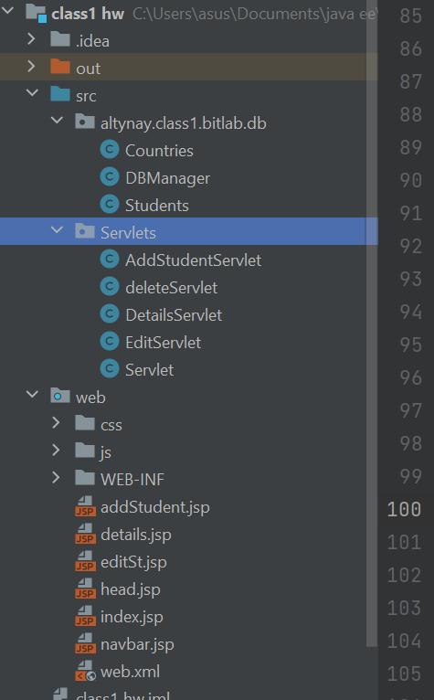

For the Java it uses 2 classes which tasks are to describe and object “Students” and “Countries”, the “DBManager” class is for connecting to database .

Different servlets classes are for implementing the different tasks according to their class name. And connect to the web application (jsp files).

As you might see the jsp files themselves are separated too and each for a specific task implementation. Unlike the program where I have a single class performing many different tasks, here I have created a several different classes , each class performing a specific specialized tasks, leading to an easy creation and modification of these classes. And it is a “High cohesion “ classes.

* Complexity of the first program with “main” ,”Engine”,”Car” classes

